ONLINE BLOOD DONATION SYSTEM
Report Submitted to
Department of Artificial Intelligence and Machine Learning
In partial fulfilment of the requirements for the degree of

BACHELOR OF SCIENCE IN ARTIFICIAL INTELLIGENCE AND MACHINE LEARNING
by

(REG.No.2428C0152)
Under the Guidance of

Mr.N.NAVEEN KUMAR



Department of Artificial Intelligence and Machine Learning

ADITHYA COLLEGE OF ARTS AND SCIENCE
(Affiliated to Bharathiar University)
Kurumbapalayam, Sathy Road,
Coimbatore-641 107

MARCH 2026

ONLINE BLOOD DONATION SYSTEM
Report Submitted to
Department of Artificial Intelligence and Machine Learning
In partial fulfilment of the requirements for the degree of

BACHELOR OF SCIENCE IN ARTIFICIAL INTELLIGENCE AND MACHINE LEARNING
by

(REG.No.2428C0152)
Under the Guidance of

Mr.N.NAVEEN KUMAR

Department of Artificial Intelligence and Machine Learning

ADITHYA COLLEGE OF ARTS AND SCIENCE
(Affiliated to Bharathiar University)
Kurumbapalayam, Sathy Road,
Coimbatore-641 107

MARCH 2026

CERTIFICATE

CERTIFICATE

This is to certify that the project work entitled “ FIRE DETECTION SYSTEM USING AURDINO IOT " submitted to the Bharathiar University in partial fulfilment of the requirements for the award of the Degree of BACHELOR OF SCIENCE IN ARTIFICIAL INTELLIGENCE AND MACHINE LEARNING is a record of original project work done by SHRIRAM.R (Reg.No. 2428C0152) during the period December 2025 – March 2026 of his study in the Department of Artificial intelligence and Machine Learning ADITHYA COLLEGE OF ARTS AND SCIENCE, COIMBATORE, affiliated to Bharathiar University, under my supervision and guidance and the project work has not formed the basis for the award of any degree or other similar title to any candidate of any University
.

Signature of the Guide

Signature of the Principal

Submitted to Viva Voce examination on ______________

Signature of the Internal Signature of the External
Examiner Examiner

ACKNOWLEDGEMENT
ACKNOWLEDGEMENT

I would like to express my sincere gratitude and appreciation to all the individuals and authorities who have contributed towards the successful completion of this project.
Firstly, I extend my heartfelt thanks to Er. C. Sukumaran, Chairman Adithya Institutions, whose unwavering support, leadership, and vision have guided us through the duration of this project. His valuable advice and encouragement have been a constant source of motivation.
My sincere thanks go to Mr. S. Praveen Kumar, Managing Trustee, Adithya Institutions, for his consistent encouragement and belief in the project's potential. His guidance has been a key factor in the development and success of this initiative.
I would like to express my gratitude to Dr. K. Srinidhi, Trustee, Adithya Institutions, for her constant support. Her leadership and commitment to excellence have set a standard for us all to follow.
A special note of thanks to Dr. R. Anuja, Principal, Adithya College of Arts and Science, for providing us with the necessary resources and opportunities to work on this project. Her academic insight and support have been essential in ensuring the smooth progress of our work.
I am deeply grateful to Mr.N.Naveen Kumar, guide and Assistant Professor, Adithya College of Arts and Science, for his continuous guidance, encouragement, and invaluable expertise. His mentorship has played an indispensable role in shaping this project, and I have learned much under his Supervision.
Finally, I would like to acknowledge the support and cooperation of all faculty members, staff, and my fellow students who have been instrumental in the successful completion of this project.

SHRIRAM.R

DECLARATION

DECLARATION

I, hereby declare that the project work entitled “ FIRE DETECTION SYSTEM USING AURDINO IOT” submitted to the Bharathiar University in partial fulfilment of the requirements for the award of the degree of BACHELOR OF SCIENCE IN ARTIFICIAL INTELLIGENCE AND MACHINE LEARNING is a record of original and independent research work done by me during period December 2025 – March 2026 under the supervision and guidance of Mr.N.Naveen Kumar Assistant professor of computer science, ADITHYA COLLEGE OF ARTS AND SCIENCE and that it has not formed the basis for the award of any Degree or other similar titled to any candidate of any University.
.

Signature of the Candidate

TABLE OF CONTENTS

S.NO | CONTENTS |  | PAGE NO
1 | INTRODUCTION |  | 3
1 | 1.1 | SYSTEM SPECIFICATION | 4
1 | 1.1.1 | HARDWARE CONFIGURATION | 4
1 | 1.1.2 | SOFTWARE SPECIFICATION | 5
2 | SYSTEM STUDY |  | 7
2 | 2.1 | EXISTING SYSTEM | 7
2 | 2.1.1 | DRAWBACKS | 8
2 | 2.2 | PROPOSED SYSTEM | 9
2 | 2.2.1 | FEATURES | 10
3 | SYSTEM DESIGN AND DEVELOPMENT |  | 12
3 | 3.1 | FILE DESIGN | 12
3 | 3.2 | INPUT DESIGN | 12
3 | 3.3 | OUTPUT DESIGN | 13
3 | 3.4 | SYSTEM DEVELOPMENT | 14
3 | 3.4.1 | DESCRIPITION OF MODULES | 15
4 | TESTING AND IMPLEMENTATION |  | 20
5 | CONCLUSION |  | 28
6 | BIBLIOGRAPHY |  | 30
7 | APPENDICES |  | 32
 | DATA FLOW DIAGRAM |  | 32
 | SAMPLE CODING |  | 0
 | SAMPLE INPUT |  | 0
 | SAMPLE OUTPUT |  | 0

ABSTRACT
The Online Blood Donation System is a web-based platform designed to bridge the gap between blood donors, recipients, and blood banks. The primary objective of the system is to simplify the process of finding compatible blood donors in emergency and non-emergency situations. The platform enables users to register as donors, search for donors based on blood group and location, and request blood through an efficient and user-friendly interface. Blood banks can also maintain real-time records of available blood units, ensuring that critical information is accessible at all times.
The proposed system eliminates the delays and manual effort involved in traditional blood donation processes by offering automated donor matching, secure user data handling, and instant communication features. By digitizing donor information and streamlining communication, the system enhances the overall reliability, transparency, and accessibility of blood donation services. This project aims to promote voluntary blood donation, ensure timely availability of blood, and support healthcare institutions in saving lives through an efficient technology-driven solution.
In addition, the system focuses on improving public awareness about blood donation by providing educational resources, eligibility guidelines, and reminders for regular donation. The platform encourages users to participate actively in blood donation drives and helps build a sustainable donor community. By integrating modern web technologies, the system delivers a convenient, secure, and socially impactful solution that supports both donors and recipients in critical times.

INTRODUCTION

INTRODUCTION
Blood is one of the most essential components in saving human lives, especially during medical emergencies, surgeries, and accidents. However, finding a suitable blood donor at the right time often becomes challenging due to the lack of proper communication channels and organized donor information. Traditional methods depend heavily on manual records maintained by hospitals or blood banks, which can be slow, inaccurate, and difficult to access during urgent situations. These limitations highlight the need for a centralized digital platform that can provide quick and reliable access to donor and blood availability details.
With the rapid growth of technology, online systems have become an effective medium for connecting people and delivering critical services. An online blood donation platform can address the inefficiencies present in the conventional setup by bringing donors, recipients, and blood banks together on a single, easy-to-use interface. Through features such as donor registration, blood group–based search, and instant communication, the system ensures that information flows smoothly and efficiently. This kind of digital approach can significantly reduce delays in arranging blood during emergencies.
The Online Blood Donation System aims to streamline and automate the entire process of blood donation and distribution. The system allows registered donors to update their availability, while recipients can search for donors based on location, blood group, and urgency. Blood banks can maintain their stock details in real time, ensuring that users can view the availability of different blood groups without physically visiting the location. This structured and systematic flow of data increases transparency and reduces confusion, making the process more dependable.
Another major advantage of the system is the encouragement of voluntary blood donation. Many people are willing to donate blood but lack awareness of where and when they are needed. By providing information about upcoming donation camps, eligibility guidelines, and reminders for regular donation, the platform motivates individuals to participate more actively. Creating a community of regular donors not only stabilizes supply during emergencies but also supports hospitals and healthcare centers in maintaining adequate blood reserves.
Overall, the Online Blood Donation System stands as a socially impactful technological solution aimed at improving healthcare services and saving lives. By replacing outdated manual practices with an efficient digital platform, the system enhances accessibility, reliability, and convenience for all users involved. It contributes to building a healthier society by ensuring timely access to life-saving blood and fostering a culture of responsible donation. The use of modern web technologies makes the system scalable, secure, and suitable for widespread implementation across different regions.
1.1.SYSTEM SPECIFICATION
The Online Blood Donation System requires a stable combination of basic hardware and software to run efficiently. On the client side, the system can operate on any standard device such as a desktop, laptop, or smartphone with a minimum of 2 GB RAM, a dual-core processor, and a modern web browser like Chrome or Firefox. On the server side, a machine with at least 4 GB RAM, adequate storage, and a reliable internet connection is needed to host the backend services and maintain smooth data exchange between users, blood banks, and administrators. This ensures the platform remains accessible anytime and from anywhere.

From a software perspective, the system is developed using common web technologies such as HTML, CSS, JavaScript for the frontend, and server-side technologies like Python, PHP, or Node.js based on the implementation choice. A relational or NoSQL database such as MySQL, PostgreSQL, or MongoDB is required to store donor details, requests, and blood availability records securely. The system also depends on a web server like Apache or Nginx for handling user requests, along with necessary frameworks and libraries for providing authentication, form validation, and database connectivity.

Functionally, the system must support key features like donor registration, user login, blood search options, request handling, and real-time availability updates from blood banks. Non-functional requirements include ensuring good performance with quick search responses, maintaining high security through encrypted password storage and restricted data access, and providing a clean and user-friendly interface suitable for all types of users. Additionally, the system must be scalable to support an increasing number of donors and recipients while maintaining reliability and data accuracy, making it suitable for long-term deployment.

1.1.1 HARDWARE REQUIREMENTS
Server-Side Hardware
- Processor: Minimum 2.0 GHz or higher
- RAM: 4 GB (8 GB recommended for better performance)
- Hard Disk: 50 GB or more
- Network: Stable broadband or hosted cloud server
- Additional: Backup storage for database and logs
Client-Side Hardware
- Processor: Dual-core or above
- RAM: Minimum 2 GB
- Storage: At least 500 MB free space
1.1.2 SOFTWARE REQUIREMENTS
• Operating System: Windows 10/11, Linux (Ubuntu 20.04+), or macOS
• Programming Language: Python 3.8+
• Frameworks & Libraries:
- FastAPI / Streamlit / Flask for UI (project dependent)
- FFmpeg for audio extraction
- Standard Python libraries (os, json, pydub, etc.)
- Pydantic for validation

SYSTEM STUDY

2.1 EXSISTING SYSTEM

In the traditional blood donation process, most activities are carried out manually by hospitals, blood banks, and healthcare centers. Donor information is often stored in physical registers or simple spreadsheets, making it difficult to retrieve accurate data quickly during emergencies. When a patient urgently needs blood, the medical staff typically contacts donors one by one through phone calls or relies on outdated records, which causes significant delays. This lack of a centralized and updated system creates inefficiency and reduces the chances of finding a suitable donor in time.
Another major limitation of the existing system is poor communication between donors and recipients. There is no direct or automated method for connecting individuals who need blood with donors who are available and willing to help. Most people come to know about blood requirements through friends, social media posts, or informal networks, which are not always reliable. As a result, the process becomes slow and depends heavily on human effort rather than a structured mechanism.
The existing system also lacks transparency regarding blood availability in various blood banks. Hospitals often maintain their own internal stock records, but these details are not easily accessible to the public. Recipients or their families may have to physically visit multiple blood banks or make repeated phone calls to check availability. This manual verification consumes precious time and increases stress during critical situations. The absence of real-time updates further contributes to confusion and misinformation.
Additionally, donor engagement and awareness are limited in the existing setup. Many willing donors do not receive timely reminders about their eligibility to donate again, nor are they informed about nearby donation camps. Blood donation drives are often advertised locally through posters or announcements, which do not reach a large audience. This lack of proper outreach prevents the creation of a consistent and active donor community that can support blood banks when needed.
Overall, the existing system is slow, disorganized, and highly dependent on physical documentation and human coordination. The absence of an integrated digital solution leads to delays, miscommunication, and inefficiency in managing donor information and blood stocks. These challenges highlight the need for a modern, automated, and user-friendly online system that can simplify the entire process, connect stakeholders effectively, and ensure timely access to lifesaving blood for patients in need.

.

2.1.1 DRAWBACKS

The primary drawback of the existing blood donation system is its heavy reliance on manual processes. Hospitals and blood banks often maintain donor records in handwritten logs or outdated spreadsheets, which makes the information difficult to retrieve quickly during emergencies. Manual searching increases the chances of errors, delays, and mismatched donor details. As a result, critical time is lost when a patient urgently needs a specific blood group, making the existing setup unreliable in high-pressure situations.
Another major issue is the lack of proper communication between donors and recipients. The current system does not provide an automated way to notify donors when blood is required. Instead, medical staff must contact donors one by one through phone calls, which is time-consuming and inefficient. Messages posted on social media or spread through informal networks may not reach suitable donors at the right time. This communication gap limits the effectiveness of the entire donation process and prevents timely support for patients.
The existing system also suffers from poor accessibility of blood availability information. Very often, recipients or their families must visit multiple blood banks to check stock or rely on outdated information from hospital staff. Since there is no centralized digital platform, real-time updates about available blood units are not easily accessible. This results in confusion, unnecessary travel, and increased stress during medical emergencies. The absence of transparency makes it harder to coordinate donor efforts and blood bank resources effectively.
Another drawback is the lack of donor engagement and motivation. Many donors are unaware of their next eligible donation date or nearby blood donation camps because the current system provides no regular reminders or awareness features. Without proper guidance and outreach, potential donors remain inactive or uninformed. This leads to inconsistent donation patterns, resulting in shortages during emergencies and overstock during other periods. The system fails to promote a healthy and sustainable donor community.
Finally, the existing system does not ensure strong data security or accuracy. Since most records are maintained manually, they are prone to loss, damage, duplication, and unauthorized access. There is no reliable method to verify donor authenticity or track past donation history accurately. This compromises the overall quality of healthcare services and poses risks to both donors and recipients. Considering these limitations, it becomes essential to implement a digital and automated solution that addresses these gaps and provides a reliable, efficient, and secure blood donation management system.

2.2 PROPOSED SYSTEM
The proposed Online Blood Donation System introduces a modern, automated, and centralized digital platform designed to overcome the limitations of the existing manual process. Instead of relying on physical registers or inconsistent communication channels, the new system provides a structured database where donor and blood bank information is stored securely and accessed in real time. This digital shift ensures that essential data can be retrieved quickly, especially during emergencies, thereby improving the overall efficiency and reliability of the donation process.
The system enables seamless interaction between donors, recipients, and blood banks through an intuitive and user-friendly interface. Donors can easily create profiles, update their availability, and receive reminders regarding their next eligible donation date. Recipients can search for donors based on blood group, location, and urgency, making the process faster and more targeted. The platform also supports instant notifications and communication features, ensuring that donors are immediately alerted when their blood group is required.
Another key aspect of the proposed system is the integration of real-time blood stock management for blood banks. Hospitals and blood banks can regularly update their available blood units, which can be viewed by users without needing to make phone calls or physical visits. This transparency helps recipients make quick decisions and reduces the stress associated with searching for blood during critical situations. The system also reduces the workload of hospital staff by automating many administrative tasks.
Security and data accuracy are major priorities in the proposed system. User information, including personal details and donation history, will be protected through secure authentication and encryption techniques. The system ensures that only authorized users can access sensitive data while eliminating the risk of record loss, duplication, or unauthorized modifications. This structured and regulated environment promotes trust and reliability among all users of the platform.
Overall, the proposed Online Blood Donation System enhances accessibility, coordination, and responsiveness in the blood donation process. By using digital technologies, the system minimizes human errors, reduces delays, and fosters a proactive donor community. It stands as an efficient, scalable, and socially impactful solution that not only simplifies blood donation but also supports healthcare institutions in providing timely medical assistance. The system ultimately aims to save lives by ensuring that blood availability is quick, accurate, and easy to access.

2.2.1. FEATURES
The proposed AI-Meeting-Summarizer system includes an advanced Automatic Speech Recognition (ASR) feature that converts spoken meeting content into accurate text. Unlike basic transcription tools, this feature relies on modern AI models capable of handling multiple speakers, varied accents, background noise, and natural conversation flow. The high-quality transcription produced by the system forms the foundation for extracting meaningful insights, improving the accuracy and reliability of meeting documentation. This automation removes the need for manual note-taking and ensures that no important detail is missed during the session.
Another major feature is its AI-powered Summarization Engine, which generates concise and structured summaries of meeting discussions. Instead of presenting users with long transcripts, the system intelligently identifies key points, decisions, tasks assigned, and important discussion topics. These insights are organized into short summaries, detailed summaries, and action item lists based on user needs. This feature significantly improves the speed and ease with which users can revisit important information, making meeting follow-ups faster and more efficient.
The system also supports multi-format input, enabling users to upload a wide range of audio and video files such as MP3, WAV, MP4, and MKV. This eliminates the need for manual format conversion and ensures compatibility with recordings from various meeting platforms like Zoom, Google Meet, Microsoft Teams, or offline sources. The flexible file-handling capability makes the system highly practical for professionals, students, and teams who use different devices or video-conferencing tools.
In addition, the platform provides a simple and user-friendly interface designed for users with all technical backgrounds. The interface allows seamless file uploads, real-time processing status, and cleanly displayed results, enabling users to access summaries and transcripts with minimal effort. The intuitive design ensures that even non-technical users can operate the system effectively without requiring training or additional software installations. This focus on usability enhances accessibility and encourages adoption across diverse environments.
Finally, the system includes essential features for speed, accuracy, and scalability, ensuring consistent performance for long or complex meetings. It can handle extended meeting durations, process large files, and deliver results efficiently without compromising accuracy. The core AI components are optimized to produce reliable summaries, even for heavy workloads, making the system suitable for corporate teams, academic researchers, and collaborative groups. Together, these features make the AI-Meeting-Summarizer a comprehensive and intelligent solution for modern meeting documentation needs.

SYSTEM DESIGN AND DEVELOPMENT

3.1 FILE DESIGN
The file design of the Online Blood Donation System plays a crucial role in organizing the various types of data required for smooth system operation. Since the platform manages donor details, recipient requests, and blood stock information, the file structure must be carefully planned to ensure accuracy and quick accessibility. A well-designed file system reduces confusion, avoids duplication, and supports efficient searching, especially during emergencies where fast retrieval of information is essential.
To manage this data effectively, the system uses structured storage files or database tables. Each file is created with specific fields to represent important attributes. For example, the donor file contains fields such as donor name, blood group, contact number, age, location, and last donation date. Similarly, the recipient file stores details like required blood group, urgency level, hospital location, and contact details. This organized approach ensures that each category of information is stored separately but remains easy to retrieve.
The file design also incorporates relational connections among different files to maintain consistency. Donor files may be linked to donation history files to track the frequency of donations and ensure medical guideline compliance. Likewise, recipient request files are associated with donor files through filtering parameters such as blood group and location. These links help automate the matching process, reducing manual intervention and improving the accuracy of search results.
Validation mechanisms are an integral part of the file design to ensure that only clean and correct data enters the system. Before saving any user input into files, the system checks for missing fields, invalid formats, or inconsistent data. For example, the system verifies whether the contact number contains the correct digits or whether the blood group entered is valid. These validations prevent errors that could otherwise affect the reliability of the platform.
To support smooth system performance, indexing methods are also included in the file design. Indexes allow faster retrieval of commonly searched information, such as blood group or location. Since emergency scenarios often demand quick matching of donors, indexed fields significantly reduce response time. This design choice ensures that large volumes of data can be handled efficiently, even as the number of donors and recipients increases over time.
Overall, the file design ensures reliability, scalability, and easy maintenance. By storing data in structured, validated, and interconnected files, the system becomes more organized and user-friendly. This arrangement not only improves system performance but also ensures that the platform remains capable of supporting future enhancements such as advanced analytics, reporting tools, or automated alerts. A strong file design forms the backbone of the Online Blood Donation System, enabling it to operate smoothly and serve its intended purpose effectively.

3.2 INPUT DESIGN
The input design of the Online Blood Donation System plays a vital role in ensuring that the data entered by users is accurate, complete, and reliable. Since the system deals with important information such as donor profiles, blood requests, and blood bank updates, the input fields must be carefully structured. Good input design helps prevent errors at the earliest stage, reducing the chances of incorrect data being processed by the system. This ultimately improves the efficiency and reliability of the platform.
The system provides different input forms for donors, recipients, and blood bank staff based on their specific roles. For donors, the input design includes fields such as name, age, gender, blood group, contact number, location, and last donation date. These fields are arranged in a simple, user-friendly format to make the registration process quick and smooth. Clear labels and placeholder text guide users on what information to enter, improving accuracy and reducing confusion.
Recipient input forms are designed to capture essential details required for requesting blood. These forms include input fields for the patient’s blood group, hospital location, type of emergency, and contact information. Dropdown menus are used for selecting blood groups, while text fields are used for explaining the urgency or specific requirements. This structured approach ensures that the system gathers all necessary information needed to match the recipient with suitable donors in the shortest possible time.
For blood banks and administrators, the input design includes forms for updating blood stock details. These forms contain input fields for blood type, available units, expiry dates, and storage conditions. Validation rules are applied to ensure that the data entered is correct—for example, the system prevents entering negative values for blood units or invalid dates. Such input validation helps maintain accurate inventory records and avoids mistakes that could affect emergency services.
Input validation checks are an essential part of the design to prevent invalid or incomplete information. The system validates fields such as contact numbers, email formats, age limits, and mandatory fields before accepting the data. If an error is detected, user-friendly error messages help guide the user to correct the input. This ensures that the stored data remains clean and consistent, reducing the workload of administrators who may otherwise need to correct mistakes manually.
Overall, the input design ensures a smooth data entry process by combining user-friendly layouts, proper field arrangements, and strong validation rules. By minimizing errors and ensuring only accurate data is accepted, the system becomes more reliable and efficient. This carefully planned input structure contributes significantly to the success of the Online Blood Donation System, enabling fast information processing, better user experience, and improved management of critical blood donation activities.

3.3 OUTPUT DESIGN
The output design of the Online Blood Donation System focuses on presenting information to users in a clear, organized, and meaningful way. Since the platform deals with sensitive and time-critical information such as donor availability, blood bank stock levels, and request statuses, the outputs must be easy to understand at a glance. Well-designed output screens help users make quick decisions, especially during emergencies when every second counts. Therefore, the primary goal of output design is to ensure clarity, accessibility, and relevance.
One of the main outputs of the system is the donor information display. After a user searches for a blood group or location, the system generates a list of matching donors. This output includes essential details such as donor name, contact number, blood group, distance from the recipient, and availability status. The information is displayed in a clean, tabular format to help users compare different donors easily. Visual indicators like color codes or icons can also be used to highlight available and unavailable donors.
Another important output is the blood request status display. Once a recipient submits a blood request, the system generates a confirmation message along with a tracking ID. This output allows the user to follow the progress of their request, check whether donors have responded, and view updates from the blood bank. A clear, structured layout helps recipients stay informed without needing to repeatedly contact hospitals or administrators. This improves transparency and reduces stress during emergencies.
For blood banks, the major output is the blood stock report. This report displays the availability of different blood groups, the quantity in units, and relevant expiry dates. The output is organized in a systematic table with proper labels and headings. Such a clear presentation allows hospital staff to quickly assess shortages and take necessary action. It also ensures that the data is accurate and easy to update, supporting smooth day-to-day operations.
Administrators also receive outputs in the form of system reports and summaries. These outputs include statistics such as the number of active donors, total blood requests received, successful matches, and upcoming donation drives. These reports help administrators monitor system performance, identify patterns, and make data-driven decisions. The outputs are presented in charts, tables, or summary cards to make the information easier to understand and analyze.
Overall, the output design ensures that all the processed information is presented clearly, accurately, and in a user-friendly manner. By offering clean layouts, well-structured tables, and informative notifications, the system improves the overall user experience. Good output design not only helps donors and recipients access critical information quickly but also supports hospitals and administrators in managing their responsibilities effectively. This contributes to a more efficient, transparent, and reliable blood donation process.

3.4 SYSTEM DEVELOPMENT
The development of the Online Blood Donation System follows a structured and systematic approach to ensure that the final application is reliable, efficient, and user-friendly. The development process begins with understanding the real-world problems present in traditional blood donation methods. Requirements are gathered from potential users such as donors, recipients, hospital staff, and blood bank administrators. This phase helps developers understand what features are necessary, what data needs to be managed, and how the system should function in emergency situations.
Once the requirements are collected, the next phase involves designing the system architecture. This includes planning how different components such as the user interface, database, backend logic, and communication modules will interact with each other. The design process ensures that the system remains scalable, secure, and easy to maintain. Diagrams such as Data Flow Diagrams (DFD), Entity-Relationship Diagrams (ERD), and flowcharts are used to visualize the structure of the system. This helps developers gain a clear understanding of how the system will operate internally.
After the design is finalized, the development team begins implementing the system using appropriate technologies. The frontend is built using web technologies like HTML, CSS, and JavaScript to create a clean and responsive user interface. The backend is developed using programming languages such as Python, PHP, or Node.js depending on the project requirements. The database is set up using MySQL, PostgreSQL, or MongoDB to store donor, recipient, and blood bank data securely. Each module is coded according to the design specifications to ensure accuracy and consistency.
Testing plays an important role in the system development process. Once the modules are implemented, various types of testing such as unit testing, integration testing, system testing, and user acceptance testing are carried out. These tests help identify bugs, logical errors, or performance issues that may affect the system’s functionality. Real-time scenarios such as urgent blood requests and donor matching are simulated to check whether the system responds correctly. Testing ensures that the system performs well before it is deployed for real use.
Deployment is the next stage where the developed and tested system is installed on a server or hosting platform. The system is configured to handle multiple users and real-time data updates. User accounts are created for donors, recipients, and administrators. During deployment, security measures such as encrypted passwords and access control mechanisms are implemented to protect sensitive information. Once deployed, the system becomes accessible to users through a web browser on computers or mobile devices.

3.4.1 DESCRIPTION OF THE MODULES
The Online Blood Donation System consists of several interconnected modules that collectively ensure smooth functioning, efficient communication, and organized management of donors, recipients, and blood banks. Each module plays a significant role in supporting the overall workflow of the application. The following section provides an expanded, detailed explanation of every module, with deeper insight into internal workings, sub-components, and functional behavior.
User Registration and Login Module
The User Registration and Login Module serves as the gateway for all users entering the system. It ensures that every user creates a valid account with accurate and authenticated information. During registration, the system collects essential details such as full name, age, gender, blood group, location, contact number, email, and desired password. These fields undergo multiple validation checks, including length restrictions, correct formatting, and avoidance of duplicate email entries. These validations help maintain the accuracy and uniqueness of user records.
This module also features strong authentication mechanisms. Passwords are stored in encrypted form using hashing techniques to maintain high security. Upon login, user credentials are compared with stored encrypted values to verify identity. Session management ensures that authenticated users remain logged in securely during their usage period without repeatedly entering passwords. The module also includes a “Forgot Password” sub-system that allows users to reset their credentials through OTP or email verification. This entire module ensures data confidentiality, privacy, and secure access control.
Another vital part of this module is user role management. The system distinguishes user roles such as Donor, Recipient, Blood Bank Staff, and Admin. Each role determines what features and interfaces the user can access. Role-based access control prevents unauthorized access to sensitive operations like stock management or system analytics. Such structured control strengthens system security while offering customized user experiences. Through this module, the system ensures that only authenticated, verified, and authorized users can access their respective functionalities.
Donor Management Module
The Donor Management Module is one of the core components of the system, as donors form the foundation of blood donation services. This module manages a comprehensive donor profile that includes name, blood group, age, address, phone number, last donation date, health conditions (if applicable), and availability status. Donors can edit and update their profiles at any time to ensure real-time accuracy of donor information. This is extremely valuable in emergency matching scenarios where up-to-date data is essential.
Another major sub-component is the Donor Eligibility Checker. This system automatically determines whether a donor is medically eligible to donate again based on the standard time gap required after each donation. The module calculates the days since the last donation and displays eligibility status to both donors and recipients. This protects donor health and ensures compliance with medical safety standards. The module may also notify donors when they become eligible again, thereby encouraging consistent participation.
The Donor History Tracker records all past donations made by each donor. This helps maintain transparency and acts as a verification tool for hospitals and administrators. It also helps build trust between donors and recipients by showing donation frequency and commitment. Overall, the Donor Management Module ensures structured record-keeping, real-time accuracy, and reliable donor availability—all crucial for smooth functioning of the platform.
Recipient Request & Donor Search Module
The Recipient Request and Donor Search Module enables recipients or their family members to quickly request blood and find suitable donors. Recipients enter details such as the required blood group, hospital location, urgency level, date of requirement, and contact information. These inputs undergo validation to ensure no essential information is missing. After the request is submitted, the system processes the details to search the database for matching donors.
Donor matching is performed through an efficient search algorithm. The system filters donors based on blood group compatibility, geographic proximity, donor availability status, and past donation records. It presents matching donors in an easy-to-read format, often including details like donor name, age, contact information, and distance from the hospital. A sorting feature helps users prioritize donors based on response speed, proximity, or availability. This ensures that recipients can quickly identify the best possible match during emergencies.
The module also supports real-time notifications to donors who meet the match criteria. Once a request is generated, donors receive alerts through SMS, email, or in-app messages. This fast and automated communication reduces delays significantly. Recipients can monitor the progress of their request through a status dashboard that updates whenever a donor responds. This module plays a vital role in reducing search time, enhancing transparency, and improving the effectiveness of the entire blood allocation process.
Blood Bank Management Module
This module primarily serves blood bank staff and administrators who handle blood stock maintenance. It allows authorized users to update stock information for each blood group, including the number of available units, storage locations, and expiration dates. Such data is stored in an organized manner and displayed to recipients in a simple, easy-to-understand format. This transparency allows users to efficiently plan their search and avoid unnecessary travel between multiple hospitals.
Another important feature is the Expiry Tracking Sub-module. Blood has a limited shelf life, and expired units must be discarded. The system automatically flags blood units that are nearing their expiration date and notifies the blood bank staff. This helps hospitals avoid wastage and ensures the freshest units are used first. The system can also generate inventory summaries that display trends, shortages, and replenishment needs.
The module also supports multi-branch functionality if a hospital has multiple blood bank units or collaborations with other centers. Each branch can update its own stock, and the system synchronizes all data to ensure accuracy. This real-time visibility benefits recipients by showing them which nearby bank carries their required blood group. By automating inventory and stock management, this module drastically improves operational efficiency and patient care.
Notification & Alerts Module
The Notification and Alerts Module ensures fast and effective communication between the system and its users. When a recipient submits a blood request, the system automatically notifies all compatible donors. Notifications can be delivered across multiple channels, including SMS, email, or in-app alerts. This increases the likelihood of donors responding quickly, which is critical during emergencies.
Notifications are trigger-based, meaning they activate when certain conditions are met. For example:
If blood stock falls below a threshold, admins receive an alert.
If a donor becomes eligible to donate again, an automated reminder is sent.
If a recipient’s request receives a donor response, the system immediately updates them.
This module also features priority-based alerts. Emergency requests are highlighted and marked as urgent before being sent to donors. This ensures immediate attention from those who are available and nearby. The module significantly enhances system responsiveness and ensures timely action across all operations.
Admin & Reporting Module
The Admin and Reporting Module gives the system administrator full control over the platform. Administrators oversee activities such as user management, donor verification, report generation, and system security. They can approve new registrations, deactivate suspicious accounts, and manage blood bank staff profiles. This ensures that all data entering the system is genuine and reliable.
This module also generates analytical reports on various system activities. Reports include donor statistics, daily or monthly blood requests, blood stock levels, and user activity logs. Visual charts and tables help admins monitor performance trends and identify problem areas. This information helps hospitals plan donation drives, predict demand, and allocate resources effectively.

TESTING AND IMPLEMENTATION

Testing and implementation are two crucial phases in the development of the Online Blood Donation System. Testing ensures that the system functions correctly, meets user needs, and performs reliably under various conditions. Implementation involves deploying the system in a real-time environment and making it available for use to donors, recipients, and administrators. Together, these phases ensure that the developed software is not only functional but also user-friendly, efficient, and ready for practical use. The following sections provide a detailed and elaborate explanation of the testing strategies, types of testing applied, test case design, implementation procedures, deployment plan, and post-implementation activities carried out for the system.
SYSTEM TESTING
System testing is performed to validate the interaction between different modules and ensure that the entire system works as intended. It verifies whether all functional and non-functional requirements have been met. The Online Blood Donation System undergoes multiple layers of testing to guarantee reliability, accuracy, and performance.
Unit Testing
Unit testing is the first and most basic level of testing. It focuses on verifying individual components or modules such as user registration, login authentication, donor search algorithm, blood request form, and stock update functions. Each unit is tested independently to ensure that there are no internal errors.
Examples of unit tests include:
- Testing whether the registration form accepts only valid email formats.
- Verifying that the donor eligibility calculator correctly identifies eligible and ineligible donors.
- Checking whether the blood request form rejects incomplete inputs.
By performing unit testing, errors are identified early in the development cycle, reducing overall project cost and effort.
Integration Testing
Integration testing ensures that different modules work smoothly when combined. The Online Blood Donation System integrates several modules such as the Donor Module, Recipient Module, Notification Module, and Blood Bank Module.
Common integration scenarios include:
- Checking whether donor details entered through the registration module correctly reflect in the donor database.
- Ensuring that the search module fetches accurate results based on data entered in the donor management module.
- Verifying whether notifications are automatically sent when a matching request is created.
Integration testing identifies inconsistencies in data flow, mismatched interfaces, and functional conflicts between modules.
3. System Testing
System testing validates the entire system as a whole. It ensures that all components collectively deliver the expected outcome. During system testing, the complete Online Blood Donation System is tested under conditions similar to real-world scenarios.
Important system testing activities include:
- Testing complete workflows such as registration → donor search → donor notification → blood donation confirmation.
- Verifying that the system responds within acceptable time limits even when multiple users are active.
- Checking whether real-time stock updates reflect immediately across the system.
System testing helps ensure that all functional and non-functional requirements have been fully satisfied.

4. Functional Testing
Functional testing checks whether the system performs all operations as required. Each function is mapped to a requirement to verify correct implementation.
Functional testing activities include:
- Checking if donors can update their availability status.
- Verifying whether recipients can submit requests without errors.
- Ensuring that admins can generate reports and view system analytics.
- Confirming that expired blood units are automatically flagged.
This testing ensures that the system is feature-complete and ready for user interaction.
5. Non-Functional Testing
Non-functional testing evaluates system performance, usability, security, and reliability.
a) Performance Testing
Performance testing ensures the system works efficiently even under heavy load.
Key performance tests include:
- Load testing (multiple simultaneous search requests)
- Stress testing (pushing system beyond limit)
- Response time evaluation
b) Security Testing
- Testing for SQL injection vulnerabilities
- Verifying password encryption
c) Usability Testing
Usability testing confirms whether the system is easy to use and navigate for all types of users.
d) Compatibility Testing
Compatibility testing ensures the system runs smoothly across browsers and devices.
6. User Acceptance Testing (UAT)
User Acceptance Testing is performed by actual users such as donors, recipients, and administrators.
They verify whether:
- The system interface is easy to understand
- Donor search results are accurate
- Blood request tracking is smooth
- Notifications are sent correctly
Once UAT is approved, the system becomes eligible for deployment.
IMPLEMENTATION
System implementation is the process of putting the developed application into practical use. The Online Blood Donation System is implemented in several planned stages to ensure smooth deployment and successful adoption by users.
System Installation
The installation phase involves setting up the required software and hardware components. This includes:
- Configuring the backend server
- Installing database management systems
- Deploying the frontend interface
- Setting up cloud or local hosting
- Ensuring stable internet connectivity
System installation also includes testing the environment to ensure that all components are correctly configured.
Database Setup
The database plays a central role in storing donor details, blood bank data, notifications, and request records. During implementation:
- Database tables are created
- Sample data is inserted for testing
- Relationships and constraints are validated
- Backup mechanisms are configured
This ensures that the system begins with a stable and secure database structure.
Module Deployment
Each module is deployed step-by-step:
- User Registration & Login Module
- Donor Management Module
- Recipient Request Module
- Blood Bank Module
- Notification & Alerts Module
- Admin Module
Deploying modules gradually helps in identifying issues early and preventing system failures.
Integration with Live Users
Once deployment is complete, real users such as donors and blood bank staff are onboarded. Training and demonstration are provided so that users can understand the features. Feedback is collected to make necessary improvements.
Pilot Testing
A pilot version of the system is launched for a small group of real users. This stage helps identify:
- Usability issues
- Performance bottlenecks
- Real-time workflow problems
- Missing features or enhancements
Based on pilot feedback, refinements are made before full launch.
Full-Scale Deployment
After resolving all issues identified during pilot testing, the system is fully deployed and made available to the public.
Full-scale implementation includes:
- Assigning admin roles
- Onboarding hospitals and blood banks
- Activating donor accounts
- Running awareness campaigns
The system becomes fully functional and ready for continuous operation.
Post-Implementation Maintenance
Even after deployment, the system requires ongoing maintenance to ensure reliability and performance.
Maintenance includes:
- Fixing bugs reported by users
- Updating software versions
- Improving features based on user feedback
- Monitoring server performance
- Securing data with regular backups
This stage ensures long-term sustainability and smooth operation of the system.
Testing and implementation are critical to ensuring that the Online Blood Donation System becomes a reliable, efficient, and user-friendly platform. Through rigorous testing processes and a structured implementation plan, the system is designed to serve donors, recipients, and blood bank staff effectively. Properly executed testing and deployment guarantee the system’s success in real-world environments and contribute to saving lives through timely blood availability.

CONCLUSION

CONCLUSION
The Online Blood Donation System successfully demonstrates how technology can be used to simplify and modernize the process of blood donation. By replacing the outdated manual system with a fully digital, automated platform, the project ensures faster access to donor information, real-time updates of blood availability, and efficient communication between donors, recipients, and blood banks. The system provides a centralized solution that benefits both the public and healthcare institutions by reducing delays, improving accuracy, and enhancing transparency.
Throughout the development process, various modules such as donor management, recipient request handling, blood bank inventory updates, notification services, and administrative controls were designed and implemented to function together seamlessly. These modules help create a smooth and user-friendly experience where users can easily register, search, notify, and update information without complications. The system’s validation mechanisms, structured file design, and secure authentication features further strengthen reliability and user trust.
This project also highlights the importance of accessibility and user engagement. By enabling features like automated alerts, donor eligibility reminders, and real-time search filters, the platform encourages active donor participation and efficient emergency response. It supports not only individuals seeking blood but also hospitals and blood banks in managing their operations more effectively.
Moreover, the system has been designed with scalability, security, and future enhancements in mind. Additional features such as mobile app integration, GPS-based donor tracking, AI-based matching suggestions, and inter-hospital networking can further improve its usefulness. The structured development and thorough testing ensure that the platform is robust, maintainable, and ready for real-world deployment.
Overall, the Online Blood Donation System stands as a meaningful and socially impactful solution that uses technology to save lives. It modernizes the donation process, strengthens coordination, and provides a reliable foundation for future improvements. The project demonstrates how computer science can contribute to public welfare, making essential services more accessible, efficient, and responsive.

BIBLIOGRAPHY

- Rajaraman, V. Fundamentals of Computer Science. PHI Learning, New Delhi, 2015.
- Shelly, G. B., & Rosenblatt, H. J. Systems Analysis and Design. Cengage Learning, 2012.
- Pressman, R. S. Software Engineering: A Practitioner’s Approach. McGraw-Hill Education, 2014.
- Sommerville, I. Software Engineering. Pearson Education, 2016.
- Elmasri, R., & Navathe, S. B. Fundamentals of Database Systems. Pearson, 2017.
- Stallings, W. Cryptography and Network Security: Principles and Practice. Pearson, 2016.
- Laudon, K. C., & Laudon, J. P. Management Information Systems. Pearson Education, 2018.
- Kurose, J. F., & Ross, K. W. Computer Networking: A Top-Down Approach. Pearson, 2017.
- National AIDS Control Organisation (NACO). Guidelines for Blood Donor Selection & Blood Donation. Government of India Publication.
- World Health Organization (WHO). Blood Safety and Availability. WHO Technical Reports.
- W3Schools. “HTML, CSS, and JavaScript Tutorials.” Retrieved from https://www.w3schools.com
- MDN Web Docs. “Web Development Documentation.” Retrieved from https://developer.mozilla.org
- GeeksforGeeks. “Database Management System Concepts.” Retrieved from https://www.geeksforgeeks.org
- TutorialsPoint. “Software Engineering Notes.” Retrieved from https://www.tutorialspoint.com
- FastAPI Documentation. “Building Modern Web APIs.” Retrieved from https://fastapi.tiangolo.com
- MySQL Official Documentation. “Database Reference Manual.” Retrieved from https://dev.mysql.com/doc

APPENDICES

DATA FLOW DIAGRAM
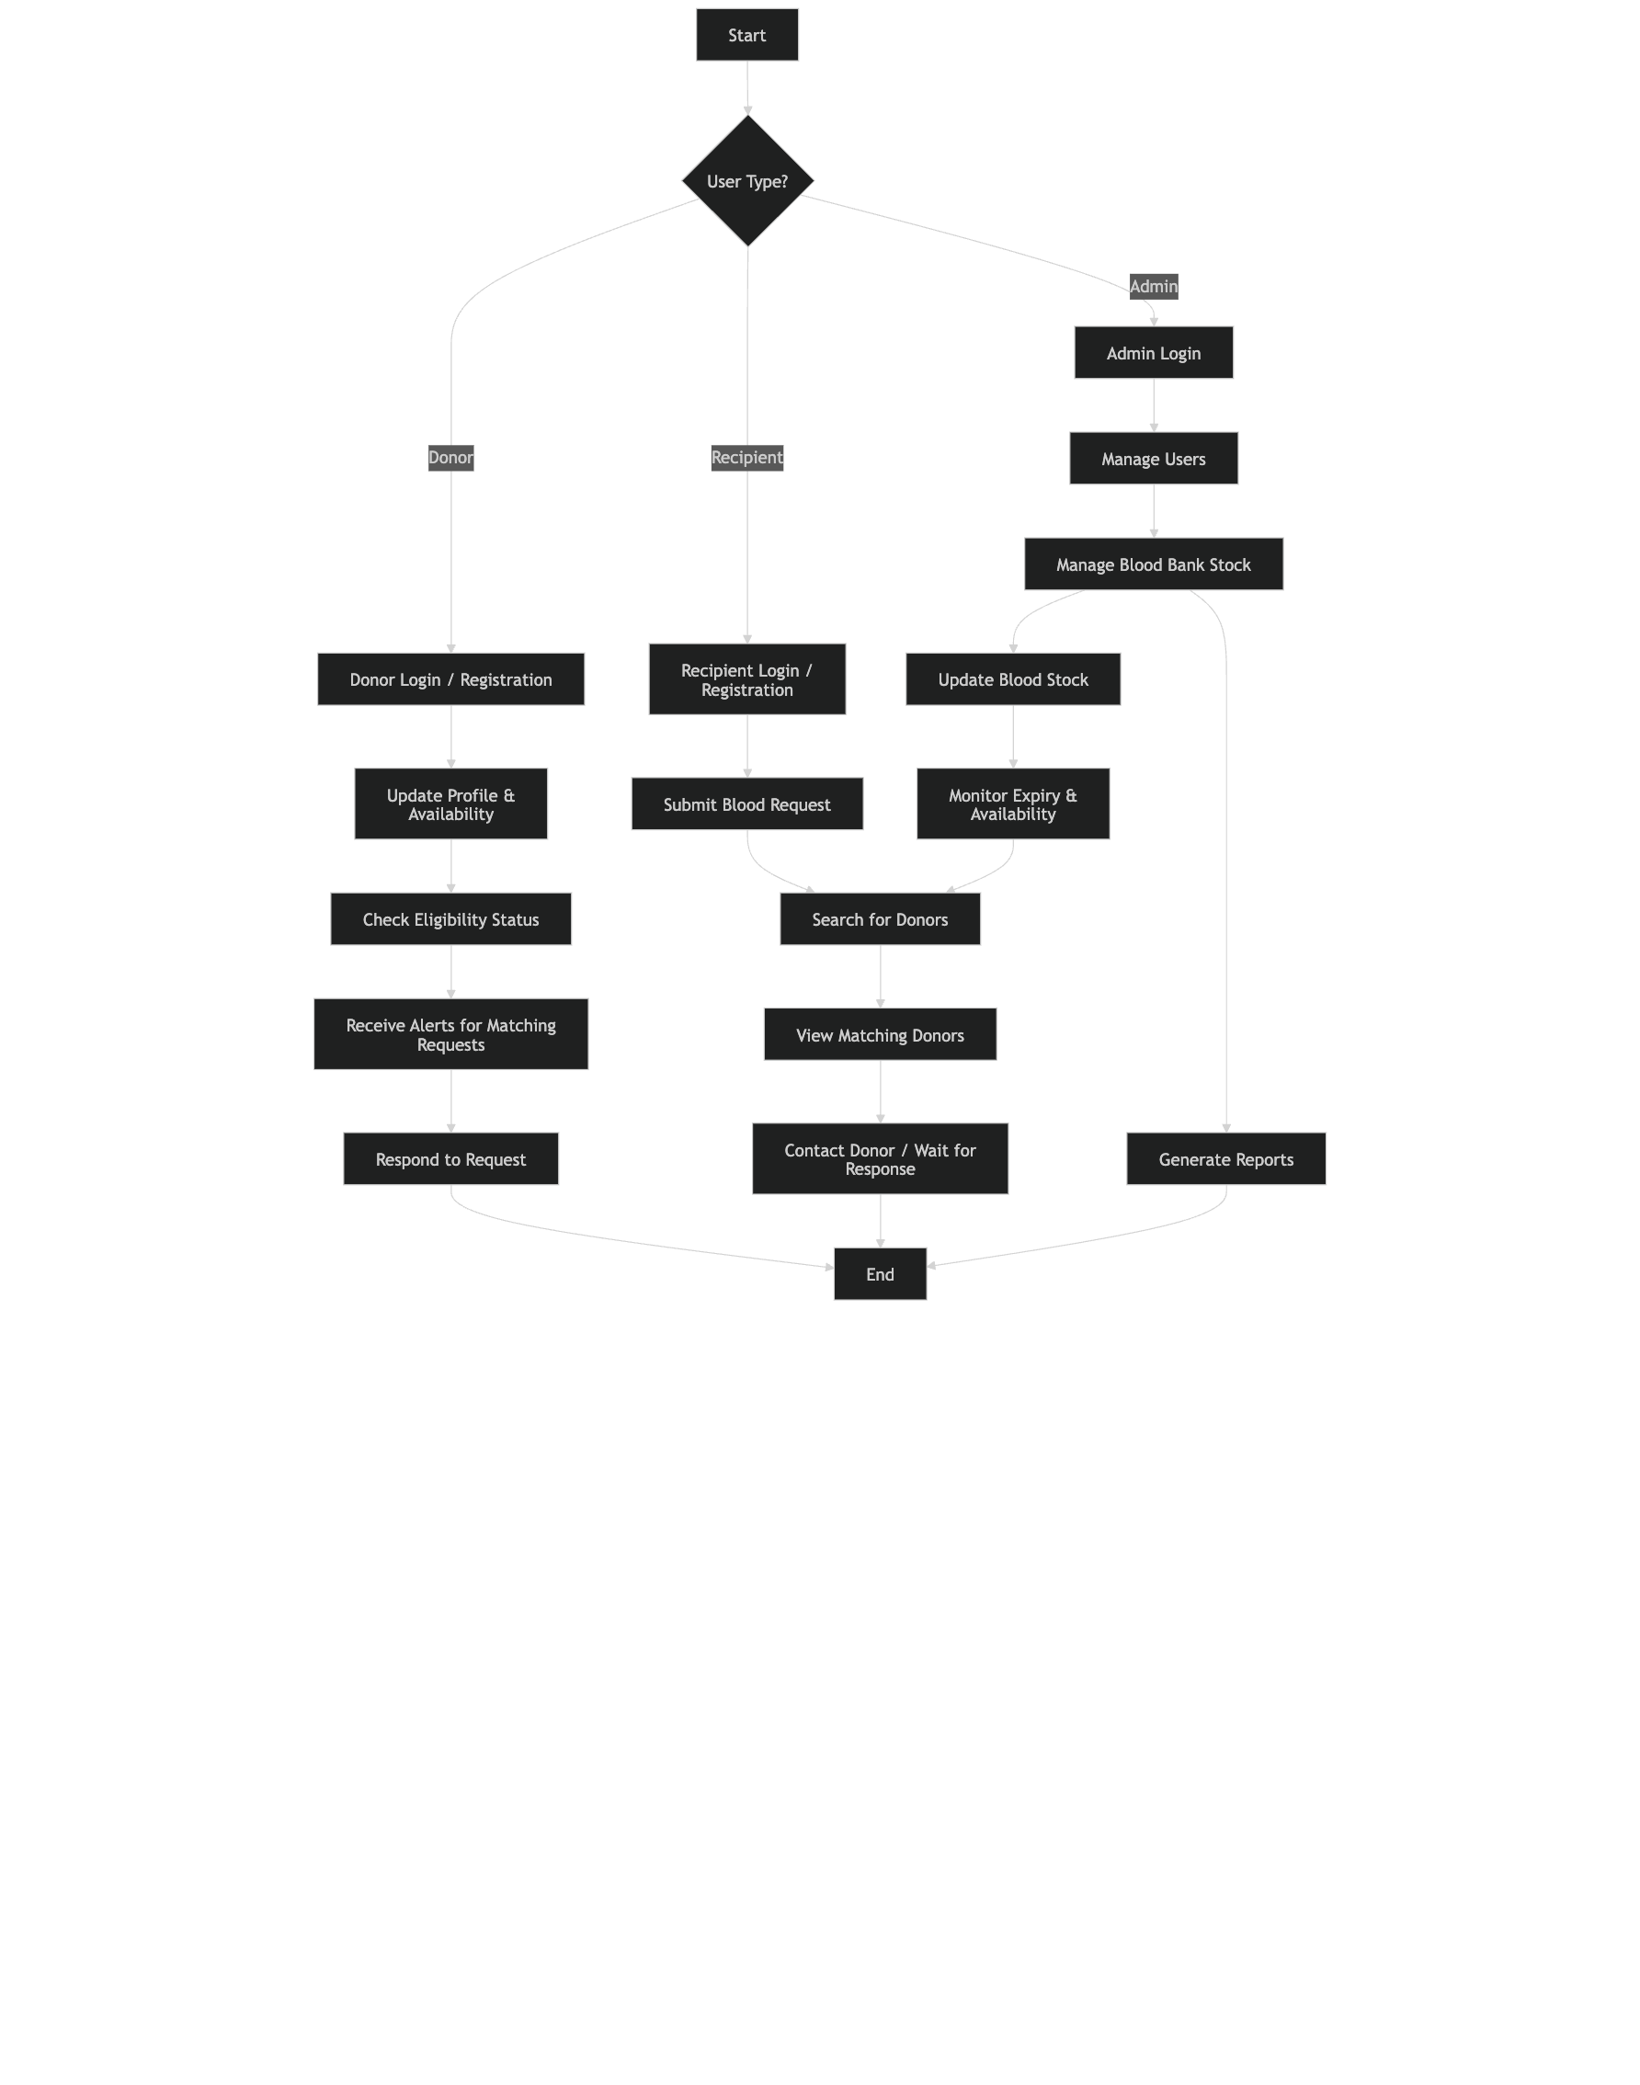

SAMPLE CODE:

import React, { useState, useEffect, useRef } from 'react';
import { useNavigate } from 'react-router-dom';
import { Card, CardContent, CardDescription, CardHeader, CardTitle } from '@/components/ui/card';
import { Button } from '@/components/ui/button';
import { Badge } from '@/components/ui/badge';
import { Progress } from '@/components/ui/progress';
import { Textarea } from '@/components/ui/textarea';
import { useToast } from '@/hooks/use-toast';
import { useAuth } from '@/context/AuthContext';
import { Navbar } from '@/components/Navbar';
import {
Brain,
Mic,
Video,
FileText,
Clock,
Users,
TrendingUp,
Upload,
Play,
Pause,
RotateCcw,
CheckCircle,
AlertCircle,
Calendar,
FileAudio,
X,
Download
} from 'lucide-react';

interface MeetingSummary {
id: string;
title: string;
date: string;
duration: string;
participants: number;
status: 'completed' | 'processing' | 'pending';
summary?: string;
actionItems?: string[];
}

interface AnalysisResult {
summary: string;
action_items: string[];
decisions: string[];
next_steps: string[];
}

export function BankingDashboard() {
const [isRecording, setIsRecording] = useState(false);
const [uploadProgress, setUploadProgress] = useState(0);
const [isUploading, setIsUploading] = useState(false);
const [analysisResult, setAnalysisResult] = useState<AnalysisResult | null>(null);
const [transcript, setTranscript] = useState('');
const [isAnalyzing, setIsAnalyzing] = useState(false);
const [uploadedFile, setUploadedFile] = useState<File | null>(null);
const [mediaRecorder, setMediaRecorder] = useState<MediaRecorder | null>(null);
const [recordedBlob, setRecordedBlob] = useState<Blob | null>(null);

const audioInputRef = useRef<HTMLInputElement>(null);
const videoInputRef = useRef<HTMLInputElement>(null);
const { toast } = useToast();
const { user, checkAuth } = useAuth();
const navigate = useNavigate();

// Handle authentication errors
const handleAuthError = () => {
toast({
title: '🔐 Authentication Required',
description: 'Please log in to continue',
variant: 'destructive',
});
navigate('/login');
};

const [recentMeetings] = useState<MeetingSummary[]>([
{
id: '1',
title: 'Weekly Team Standup',
date: '2026-01-08',
duration: '45 min',
participants: 8,
status: 'completed',
summary: 'Discussed Q1 goals and sprint planning',
actionItems: ['Update project timeline', 'Review budget allocation']
},
{
id: '2',
title: 'Client Presentation',
date: '2026-01-07',
duration: '60 min',
participants: 5,
status: 'processing'
},
{
id: '3',
title: 'Product Strategy Meeting',
date: '2026-01-06',
duration: '90 min',
participants: 12,
status: 'completed',
summary: 'Product roadmap and feature prioritization',
actionItems: ['Finalize feature specs', 'Schedule user testing', 'Update design system']
}
]);

const handleStartRecording = async () => {
try {
const stream = await navigator.mediaDevices.getUserMedia({ audio: true });
const recorder = new MediaRecorder(stream);
const chunks: Blob[] = [];

recorder.ondataavailable = (e) => {
if (e.data.size > 0) {
chunks.push(e.data);
}
};

recorder.onstop = () => {
const blob = new Blob(chunks, { type: 'audio/webm' });
setRecordedBlob(blob);
stream.getTracks().forEach(track => track.stop());
};

recorder.start();
setMediaRecorder(recorder);
setIsRecording(true);

toast({
title: '🎤 Recording Started',
description: 'Your meeting is being recorded...',
});
} catch (error) {
toast({
title: '❌ Recording Failed',
description: 'Could not access microphone. Please check permissions.',
variant: 'destructive',
});
}
};

const handleStopRecording = async () => {
if (mediaRecorder && mediaRecorder.state !== 'inactive') {
mediaRecorder.stop();
setIsRecording(false);
setMediaRecorder(null);

toast({
title: '⏹️ Recording Stopped',
description: 'Processing your recording...',
});

// Wait for the blob to be set, then automatically upload
setTimeout(() => {
if (recordedBlob) {
const file = new File([recordedBlob], `recording-${Date.now()}.webm`, {
type: 'audio/webm'
});
handleFileUpload(file, 'audio');
}
}, 500);
}
};

const handleFileUpload = async (file: File, fileType: 'audio' | 'video') => {
if (!file) return;

// Validate file size (50MB limit)
const maxSize = 50 * 1024 * 1024; // 50MB
if (file.size > maxSize) {
toast({
title: '❌ File Too Large',
description: 'Please select a file smaller than 50MB.',
variant: 'destructive',
});
return;
}

// Validate file type
const audioTypes = ['audio/mp3', 'audio/wav', 'audio/m4a', 'audio/flac', 'audio/ogg', 'audio/aac', 'audio/webm'];
const videoTypes = ['video/mp4', 'video/avi', 'video/mov', 'video/mkv', 'video/wmv', 'video/flv'];
const allowedTypes = fileType === 'audio' ? audioTypes : videoTypes;

if (!allowedTypes.some(type => file.type === type || file.name.toLowerCase().endsWith(type.split('/')[1]))) {
toast({
title: '❌ Invalid File Type',
description: `Please select a valid ${fileType} file.`,
variant: 'destructive',
});
return;
}

setIsUploading(true);
setUploadProgress(0);
setUploadedFile(file);
setAnalysisResult(null);

const formData = new FormData();
formData.append('file', file);

try {
toast({
title: `📁 Uploading ${fileType}...`,
description: `Processing ${file.name}`,
});

// Real progress tracking
const xhr = new XMLHttpRequest();

xhr.upload.onprogress = (e) => {
if (e.lengthComputable) {
const percentComplete = Math.round((e.loaded / e.total) * 90); // Reserve 10% for processing
setUploadProgress(percentComplete);
}
};

const uploadPromise = new Promise<any>((resolve, reject) => {
xhr.onload = () => {
if (xhr.status === 401) {
handleAuthError();
reject(new Error('Authentication required'));
} else if (xhr.status === 200) {
resolve(JSON.parse(xhr.responseText));
} else {
const errorResponse = JSON.parse(xhr.responseText);
reject(new Error(errorResponse.detail || `Upload failed: ${xhr.statusText}`));
}
};
xhr.onerror = () => reject(new Error('Network error during upload'));
});

xhr.open('POST', 'http://localhost:8000/api/upload');
xhr.withCredentials = true;
xhr.send(formData);

const result = await uploadPromise;
setUploadProgress(100);

// Set transcript and analysis results
setTranscript(result.transcript);
setAnalysisResult(result.analysis);

toast({
title: '✅ Analysis Complete!',
description: `Successfully processed ${result.filename}`,
});

} catch (error: any) {
console.error('Upload error:', error);
toast({
title: '❌ Upload Failed',
description: error.message || 'Failed to process file. Please try again.',
variant: 'destructive',
});
setUploadProgress(0);
} finally {
setIsUploading(false);
}
};

const handleAudioUpload = () => {
audioInputRef.current?.click();
};

const handleVideoUpload = () => {
videoInputRef.current?.click();
};

const onAudioFileSelect = (event: React.ChangeEvent<HTMLInputElement>) => {
const file = event.target.files?.[0];
if (file) {
handleFileUpload(file, 'audio');
}
};

const onVideoFileSelect = (event: React.ChangeEvent<HTMLInputElement>) => {
const file = event.target.files?.[0];
if (file) {
handleFileUpload(file, 'video');
}
};

const handleTranscriptAnalysis = async () => {
if (!transcript.trim()) {
toast({
title: '⚠️ No Transcript',
description: 'Please enter a transcript to analyze',
variant: 'destructive',
});
return;
}

if (transcript.trim().length < 50) {
toast({
title: '⚠️ Transcript Too Short',
description: 'Please provide a more detailed transcript (at least 50 characters)',
variant: 'destructive',
});
return;
}

setIsAnalyzing(true);
setAnalysisResult(null);

try {
const response = await fetch('http://localhost:8000/api/analyze-transcript', {
method: 'POST',
headers: {
'Content-Type': 'application/json',
},
credentials: 'include',
body: JSON.stringify({ transcript: transcript.trim() }),
});

if (!response.ok) {
if (response.status === 401) {
handleAuthError();
return;
}
const errorData = await response.json();
throw new Error(errorData.detail || 'Analysis failed');
}

const result = await response.json();

if (!result.analysis) {
throw new Error('Invalid response from server');
}

setAnalysisResult(result.analysis);

toast({
title: '🧠 Analysis Complete!',
description: 'Successfully analyzed your transcript',
});

} catch (error: any) {
console.error('Analysis error:', error);
toast({
title: '❌ Analysis Failed',
description: error.message || 'Failed to analyze transcript. Please try again.',
variant: 'destructive',
});
} finally {
setIsAnalyzing(false);
}
};

const clearResults = () => {
setAnalysisResult(null);
setTranscript('');
setUploadedFile(null);
setUploadProgress(0);
setRecordedBlob(null);
};

const exportResults = () => {
if (!analysisResult) return;

const exportData = {
timestamp: new Date().toISOString(),
summary: analysisResult.summary,
actionItems: analysisResult.action_items,
decisions: analysisResult.decisions,
nextSteps: analysisResult.next_steps,
originalTranscript: transcript
};

const blob = new Blob([JSON.stringify(exportData, null, 2)], {
type: 'application/json'
});

const url = URL.createObjectURL(blob);
const a = document.createElement('a');
a.href = url;
a.download = `meeting-analysis-${new Date().toISOString().split('T')[0]}.json`;
document.body.appendChild(a);
a.click();
document.body.removeChild(a);
URL.revokeObjectURL(url);

toast({
title: '📥 Export Complete!',
description: 'Analysis results have been downloaded',
});
};

return (
<div className="min-h-screen w-full bg-gradient-to-br from-slate-50 via-blue-50 to-indigo-100 dark:from-slate-900 dark:via-slate-800 dark:to-indigo-900">
<Navbar />
{/* Hidden file inputs */}
<input
type="file"
ref={audioInputRef}
onChange={onAudioFileSelect}
accept=".mp3,.wav,.m4a,.flac,.ogg,.aac"
style={{ display: 'none' }}
/>
<input
type="file"
ref={videoInputRef}
onChange={onVideoFileSelect}
accept=".mp4,.avi,.mov,.mkv,.wmv,.flv"
style={{ display: 'none' }}
/>

{/* Welcome Header */}
<div className="text-center py-12 px-8">
<div className="max-w-4xl mx-auto">
{user && (
<div className="mb-4">
<Badge variant="outline" className="px-4 py-2 text-sm font-medium">
Welcome back, {user.username}! 👋
</Badge>
</div>
)}
<h1 className="text-5xl md:text-6xl font-bold bg-gradient-to-r from-blue-600 via-purple-600 to-indigo-600 bg-clip-text text-transparent mb-4 leading-tight">
AI Meeting Assistant
</h1>
<p className="text-xl md:text-2xl text-slate-600 dark:text-slate-300 font-light">
Transform your meetings into actionable insights with AI-powered analysis
</p>
</div>
</div>

{/* Main Content */}
<div className="max-w-5xl mx-auto px-6 pb-12 space-y-8">
{/* Meeting Actions */}
<div className="space-y-6">
{/* Quick Actions */}
<Card className="bg-white/70 dark:bg-slate-800/70 backdrop-blur-sm border-0 shadow-2xl shadow-blue-500/10">
<CardHeader className="pb-6">
<CardTitle className="flex items-center gap-3 text-2xl font-bold text-slate-800 dark:text-slate-100">
<div className="p-2 bg-gradient-to-r from-blue-500 to-purple-600 rounded-xl">
<Brain className="h-6 w-6 text-white" />
</div>
Quick Actions
</CardTitle>
<CardDescription className="text-lg text-slate-600 dark:text-slate-300">
Start a new meeting session or upload existing content
</CardDescription>
</CardHeader>
<CardContent>
<div className="grid grid-cols-1 md:grid-cols-3 gap-6">
<Button
onClick={isRecording ? handleStopRecording : handleStartRecording}
className={`h-24 flex flex-col items-center gap-3 text-white font-semibold text-base transition-all duration-200 transform hover:scale-105 ${isRecording ? 'bg-gradient-to-r from-red-500 to-red-600 hover:from-red-600 hover:to-red-700 shadow-lg shadow-red-500/30' : 'bg-gradient-to-r from-green-500 to-green-600 hover:from-green-600 hover:to-green-700 shadow-lg shadow-green-500/30'}`}
disabled={isUploading}
>
{isRecording ? <Pause className="h-7 w-7" /> : <Mic className="h-7 w-7" />}
{isRecording ? 'Stop Recording' : 'Start Recording'}
</Button>

<Button
onClick={handleAudioUpload}
variant="outline"
className="h-24 flex flex-col items-center gap-3 border-2 border-blue-200 dark:border-blue-800 bg-gradient-to-r from-blue-50 to-blue-100 dark:from-blue-900/20 dark:to-blue-800/20 hover:from-blue-100 hover:to-blue-200 dark:hover:from-blue-800/30 dark:hover:to-blue-700/30 text-blue-700 dark:text-blue-300 font-semibold text-base transition-all duration-200 transform hover:scale-105 shadow-md hover:shadow-lg"
disabled={isUploading}
>
<FileAudio className="h-7 w-7" />
Upload Audio
</Button>

<Button
onClick={handleVideoUpload}
variant="outline"
className="h-24 flex flex-col items-center gap-3 border-2 border-purple-200 dark:border-purple-800 bg-gradient-to-r from-purple-50 to-purple-100 dark:from-purple-900/20 dark:to-purple-800/20 hover:from-purple-100 hover:to-purple-200 dark:hover:from-purple-800/30 dark:hover:to-purple-700/30 text-purple-700 dark:text-purple-300 font-semibold text-base transition-all duration-200 transform hover:scale-105 shadow-md hover:shadow-lg"
disabled={isUploading}
>
<Video className="h-7 w-7" />
Upload Video
</Button>
</div>

{/* Upload Progress */}
{isUploading && (
<div className="mt-8 p-6 bg-gradient-to-r from-blue-50 to-indigo-50 dark:from-blue-900/20 dark:to-indigo-900/20 rounded-xl border border-blue-200 dark:border-blue-800">
<div className="flex justify-between items-center mb-3">
<span className="text-base font-semibold text-blue-800 dark:text-blue-200">Processing {uploadedFile?.name}...</span>
<span className="text-base font-bold text-blue-600 dark:text-blue-400">{uploadProgress}%</span>
</div>
<Progress value={uploadProgress} className="h-3 bg-blue-100 dark:bg-blue-900" />
</div>
)}

{/* File Upload Success */}
{uploadedFile && !isUploading && uploadProgress === 100 && (
<div className="mt-8 p-6 bg-gradient-to-r from-green-50 to-emerald-50 dark:from-green-900/20 dark:to-emerald-900/20 border border-green-200 dark:border-green-800 rounded-xl shadow-lg">
<div className="flex items-center justify-between">
<div className="flex items-center gap-3">
<CheckCircle className="h-6 w-6 text-green-600" />
<span className="text-base font-semibold text-green-800 dark:text-green-200">
{uploadedFile.name} processed successfully!
</span>
</div>
<Button size="sm" variant="ghost" onClick={clearResults} className="hover:bg-green-100 dark:hover:bg-green-900/30">
<X className="h-5 w-5" />
</Button>
</div>
</div>
)}
</CardContent>
</Card>

{/* Transcript Input */}
<Card className="bg-white/70 dark:bg-slate-800/70 backdrop-blur-sm border-0 shadow-2xl shadow-purple-500/10">
<CardHeader className="pb-6">
<CardTitle className="flex items-center gap-3 text-2xl font-bold text-slate-800 dark:text-slate-100">
<div className="p-2 bg-gradient-to-r from-purple-500 to-indigo-600 rounded-xl">
<FileText className="h-6 w-6 text-white" />
</div>
Paste Transcript
</CardTitle>
<CardDescription className="text-lg text-slate-600 dark:text-slate-300">
Or paste your meeting transcript for instant analysis
</CardDescription>
</CardHeader>
<CardContent className="space-y-6">
<Textarea
placeholder="Paste your meeting transcript here..."
value={transcript}
onChange={(e) => setTranscript(e.target.value)}
className="min-h-[140px] resize-none text-base bg-slate-50 dark:bg-slate-900/50 border-slate-200 dark:border-slate-700 rounded-xl focus:ring-2 focus:ring-purple-500 focus:border-transparent transition-all"
disabled={isUploading}
/>
<Button
onClick={handleTranscriptAnalysis}
disabled={!transcript.trim() || isAnalyzing || isUploading}
className="w-full h-14 bg-gradient-to-r from-purple-500 via-indigo-600 to-blue-600 hover:from-purple-600 hover:via-indigo-700 hover:to-blue-700 text-white font-semibold text-lg shadow-lg shadow-purple-500/30 transition-all duration-200 transform hover:scale-[1.02]"
>
{isAnalyzing ? (
<>
<div className="animate-spin rounded-full h-5 w-5 border-b-2 border-white mr-3"></div>
Analyzing...
</>
) : (
<>
<Brain className="mr-3 h-5 w-5" />
Analyze Transcript
</>
)}
</Button>
</CardContent>
</Card>

{/* Analysis Results */}
{analysisResult && (
<Card className="bg-white/80 dark:bg-slate-800/80 backdrop-blur-sm border-0 shadow-2xl shadow-green-500/10 animate-in slide-in-from-bottom-4 duration-500">
<CardHeader className="pb-6 bg-gradient-to-r from-green-50 to-emerald-50 dark:from-green-900/20 dark:to-emerald-900/20 rounded-t-xl">
<CardTitle className="flex items-center gap-3 text-2xl font-bold text-green-800 dark:text-green-200">
<div className="p-2 bg-gradient-to-r from-green-500 to-emerald-600 rounded-xl">
<CheckCircle className="h-6 w-6 text-white" />
</div>
Analysis Results
</CardTitle>
</CardHeader>
<CardContent className="space-y-6">
{/* Summary */}
<div>
<h3 className="font-bold text-lg mb-4 flex items-center gap-3 text-slate-800 dark:text-slate-200">
<FileText className="w-5 h-5 text-blue-600" />
Meeting Summary
</h3>
<Card className="bg-gradient-to-r from-blue-50 to-indigo-50 dark:from-blue-900/20 dark:to-indigo-900/20 border border-blue-200 dark:border-blue-800">
<CardContent className="p-6">
<p className="text-base leading-relaxed text-slate-700 dark:text-slate-300">{analysisResult.summary}</p>
</CardContent>
</Card>
</div>

{/* Action Items */}
{analysisResult.action_items.length > 0 && (
<div>
<h3 className="font-bold text-lg mb-4 flex items-center gap-3 text-slate-800 dark:text-slate-200">
<CheckCircle className="w-5 h-5 text-blue-600" />
Action Items ({analysisResult.action_items.length})
</h3>
<div className="space-y-3">
{analysisResult.action_items.map((item, index) => (
<Card key={index} className="bg-gradient-to-r from-blue-50 to-cyan-50 dark:from-blue-900/20 dark:to-cyan-900/20 border border-blue-200 dark:border-blue-800 hover:shadow-md transition-all duration-200 animate-in slide-in-from-left-2" style={{animationDelay: `${index * 100}ms`}}>
<CardContent className="p-4">
<div className="flex items-start gap-3">
<div className="w-3 h-3 bg-gradient-to-r from-blue-500 to-cyan-600 rounded-full mt-1.5 flex-shrink-0 shadow-sm"></div>
<span className="text-base text-slate-700 dark:text-slate-300 leading-relaxed">{item}</span>
</div>
</CardContent>
</Card>
))}
</div>
</div>
)}

{/* Decisions */}
{analysisResult.decisions.length > 0 && (
<div>
<h3 className="font-bold text-lg mb-4 flex items-center gap-3 text-slate-800 dark:text-slate-200">
<CheckCircle className="w-5 h-5 text-purple-600" />
Key Decisions ({analysisResult.decisions.length})
</h3>
<div className="space-y-3">
{analysisResult.decisions.map((decision, index) => (
<Card key={index} className="bg-gradient-to-r from-purple-50 to-pink-50 dark:from-purple-900/20 dark:to-pink-900/20 border border-purple-200 dark:border-purple-800 hover:shadow-md transition-all duration-200 animate-in slide-in-from-left-2" style={{animationDelay: `${index * 100}ms`}}>
<CardContent className="p-4">
<div className="flex items-start gap-3">
<div className="w-3 h-3 bg-gradient-to-r from-purple-500 to-pink-600 rounded-full mt-1.5 flex-shrink-0 shadow-sm"></div>
<span className="text-base text-slate-700 dark:text-slate-300 leading-relaxed">{decision}</span>
</div>
</CardContent>
</Card>
))}
</div>
</div>
)}

{/* Next Steps */}
{analysisResult.next_steps.length > 0 && (
<div>
<h3 className="font-bold text-lg mb-4 flex items-center gap-3 text-slate-800 dark:text-slate-200">
<TrendingUp className="w-5 h-5 text-orange-600" />
Next Steps ({analysisResult.next_steps.length})
</h3>
<div className="space-y-3">
{analysisResult.next_steps.map((step, index) => (
<Card key={index} className="bg-gradient-to-r from-orange-50 to-amber-50 dark:from-orange-900/20 dark:to-amber-900/20 border border-orange-200 dark:border-orange-800 hover:shadow-md transition-all duration-200 animate-in slide-in-from-left-2" style={{animationDelay: `${index * 100}ms`}}>
<CardContent className="p-4">
<div className="flex items-start gap-3">
<div className="w-3 h-3 bg-gradient-to-r from-orange-500 to-amber-600 rounded-full mt-1.5 flex-shrink-0 shadow-sm"></div>
<span className="text-base text-slate-700 dark:text-slate-300 leading-relaxed">{step}</span>
</div>
</CardContent>
</Card>
))}
</div>
</div>
)}

{/* Actions */}
<div className="flex gap-4 pt-4">
<Button onClick={exportResults} className="flex-1 h-12 bg-gradient-to-r from-green-500 to-emerald-600 hover:from-green-600 hover:to-emerald-700 text-white font-semibold shadow-lg shadow-green-500/30 transition-all duration-200 transform hover:scale-[1.02]">
<Download className="w-5 h-5 mr-2" />
Export Results
</Button>
<Button variant="outline" onClick={clearResults} className="h-12 px-8 border-2 border-slate-300 dark:border-slate-600 hover:bg-slate-100 dark:hover:bg-slate-800 font-semibold transition-all duration-200">
Clear Results
</Button>
</div>
</CardContent>
</Card>
)}
</div>
</div>
</div>
);
}

SAMPLE INPUT

Registration Page:

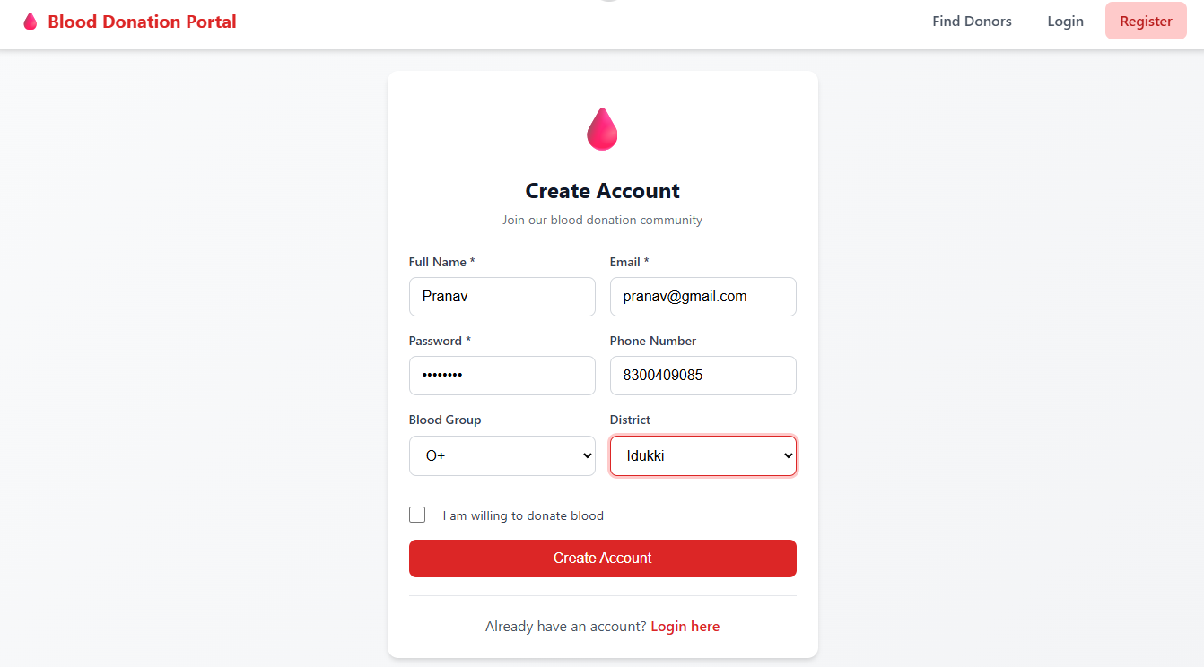

Login Page:
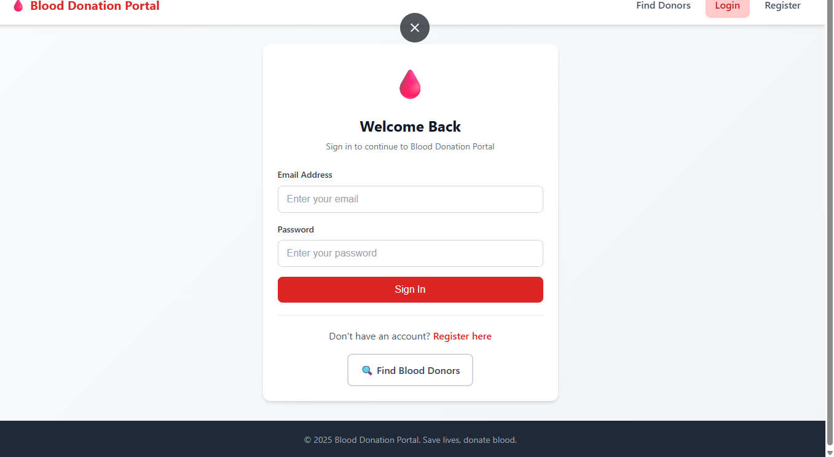

Dashboard Page:

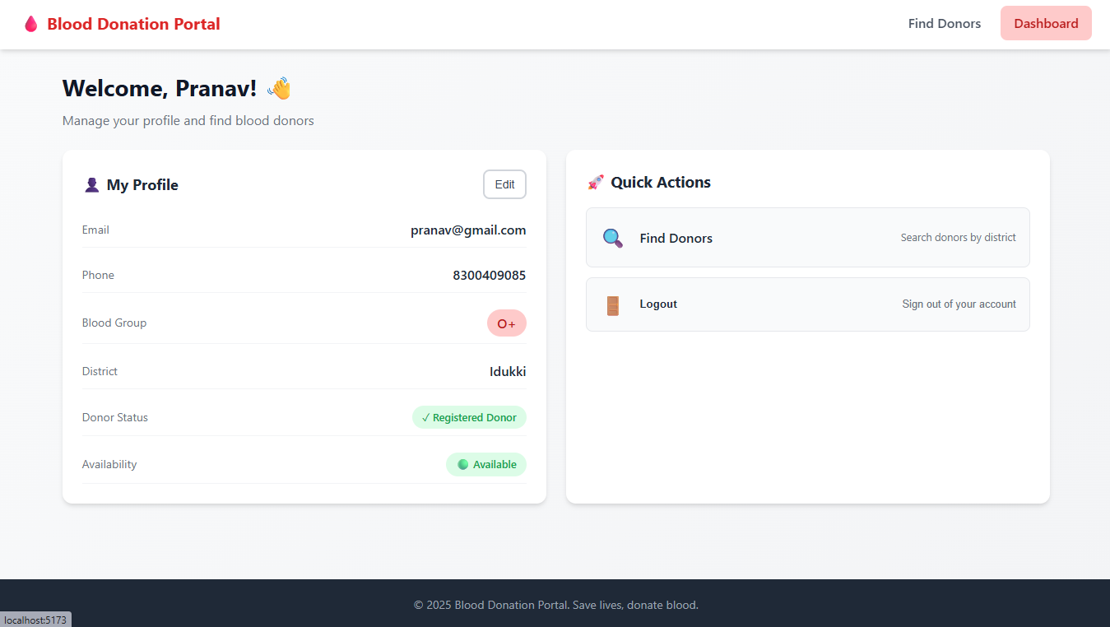

SAMPLE OUTPUT:

BLOOD DONORS:

